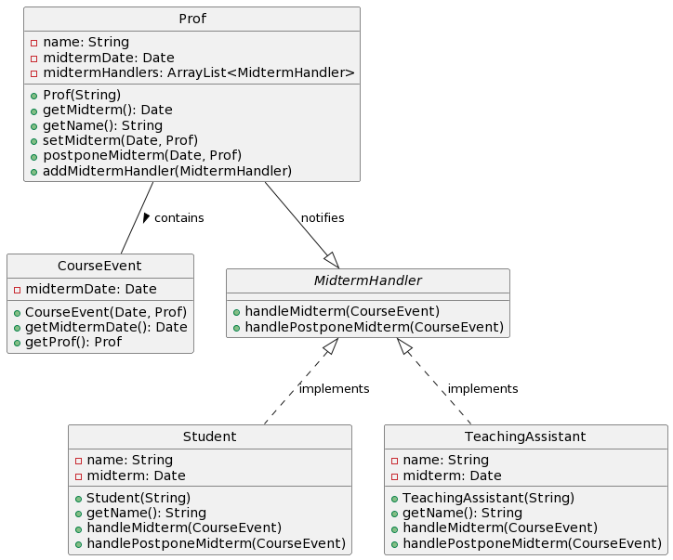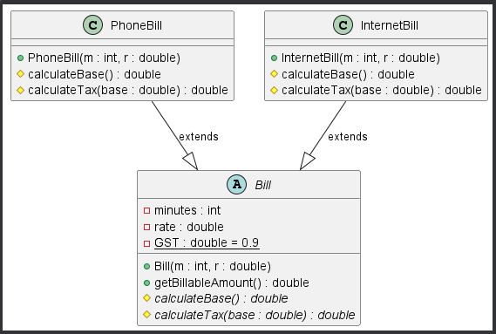

String Builder vs String

Delegation from inheritance

Observer Pattern

Regex Pattern Matching

Strategy Pattern

Template Method Refactoring

Template Method Refactoring

MVC Todolist Composite, XML, Serialization